**GROUP 9**

**EXPERIMENT 6**

**OBJECTIVE:** LED ON/OFF USING BLYNK APP

**BLOCK DIAGRAM:**

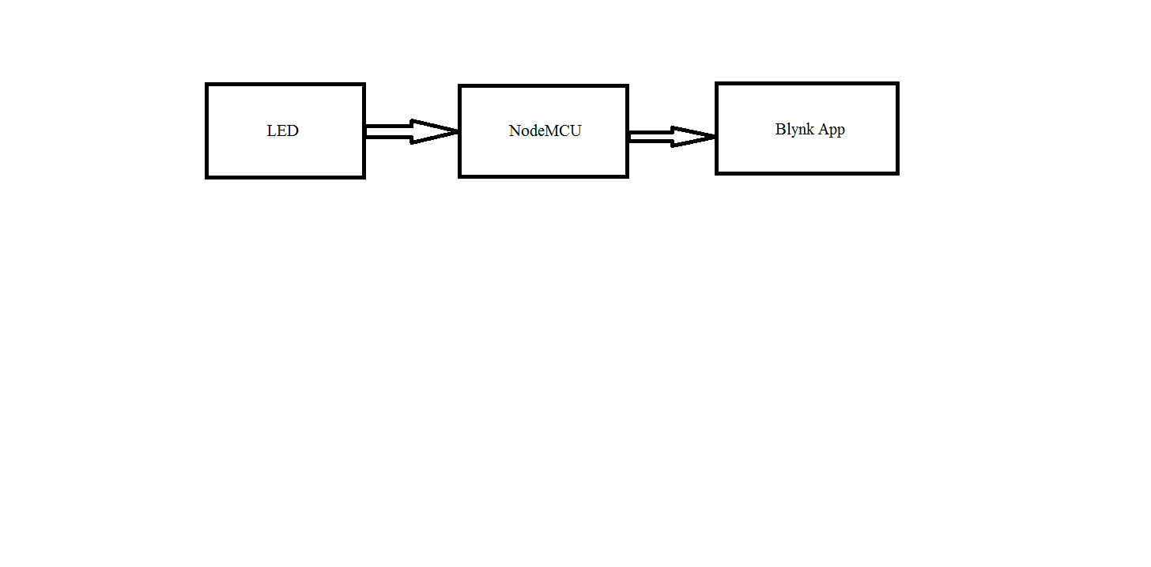

**Fig 1A**

**EXPLANATION:**

LED is connected with resistor in a breadboard. Then via ESP8266 wi-fi module in NodeMCU, D3 pin of the LED is connected to Blynk app. Now the switching on/off of LED is controlled by a switch added in the Blynk app interface.

**APPARATUS:**

* LED
* Resistor
* Jumper wires
* NodeMCU
* Blynk app

**PROGRAM:**

#include <BlynkSimpleEsp8266.h>

int RED_LED=D1;

char auth[] = "hosEitmcOMgVentoZ17g0jPdGot_tWYX";

char ssid[] = "Codermaker";

char pass[] = "babi1pal";

void setup() {

Serial.begin(115200);

pinMode(D3,OUTPUT);

Blynk.begin(auth, ssid, pass);

}

void loop() {

Blynk.run();

delay(1000);

}

BLYNK_WRITE(V0){

int a=param.asInt();

if(a==1)

digitalWrite(RED_LED,1);

else

digitalWrite(RED_LED,0);

}

**RESULT:**

OFF:

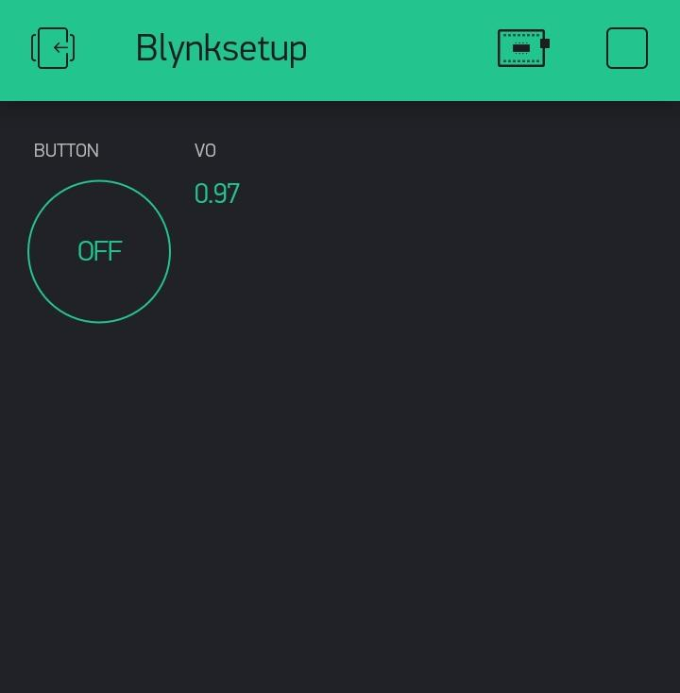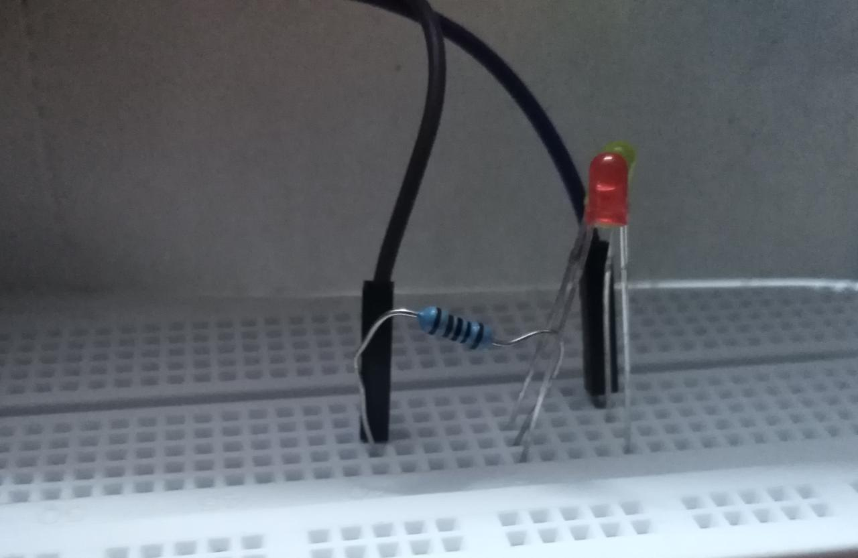

**FIG 1B**

ON:

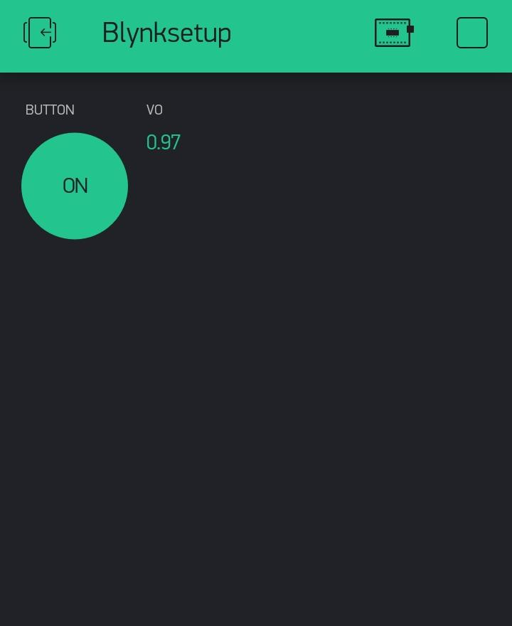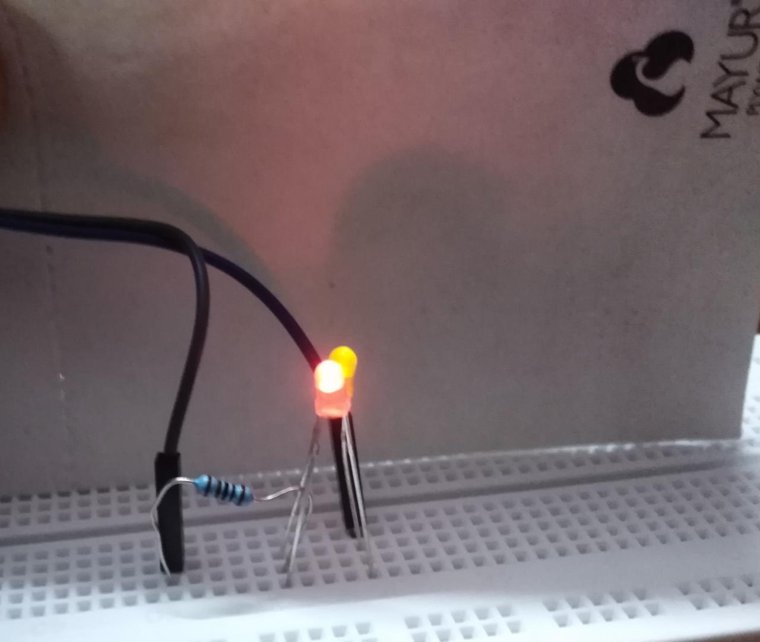

**FIG 1C**